Features of Java [WORA]
Java is guaranteed to be Write Once, Run Anywhere.
Features of any programming language are nothing but the services or basic facilities provided by the language to the industry programmers. The language Java provides 13 features. They are:
- Simple.
- Platform-Independent.
- Architectural Neutral.
- Portable.
- Multi-threaded.
- Networked.
- Distributed.
- High-Performance.
- Interpreted.
- Dynamic
- Robust(Strong)
- Secured and
- Object Oriented programming language.

- Simple:
Java is simple because of the following factors:
- Java is easy to write and more readable and eye-catching. Java programming language contains user friendly syntaxes, so that one can develop effective applications compared to all the programming languages Java syntax are so easy.
- Java will execute its applications within less execution time and within less memory.
- Syntax is based on C++ (so easier for programmers to learn it after C++). Java has taken all the simplified syntaxes from C and C++. Java has not defined any confusion oriented syntaxes.
- Removed many confusing and/or rarely-used features e.g., explicit pointers, operator overloading etc.
- Java programming doesn’t support pointers. Hence we get less application development time and less execution time because of the magic of byte code.
Note: Byte code is the set of optimized instructions generated by Java compiler during compilation phase. The nature of the byte code is so faster than ordinary pointer code.
- No need to remove unreferenced objects because there is Automatic Garbage Collection in java.
Garbage Collector:
A garbage collector is the system background Java program which is running along with the regular Java program for collecting unused/unreferenced memory space for improving the performance of java application.
Garbage collector program runs internally along with our Java program for regular periodical intervals of time.
Note: Java programming language doesn’t contain destructors (like C++). In place of destructors we have garbage collector program.
- Java programming contains rich set of API (Application Programming Interface).
API:
An API is a collection of packages. A package is a collection of classes, interfaces and sub-packages. A sub-package is a collection of classes, interfaces and sub-sub-packages.
- Java has a concise, cohesive set of features that makes it easy to learn and use.
- Platform-Independent:
Platform:
A platform is the hardware or software environment in which a program runs.

There are two types of platforms:
a) Software-based and
b) Hardware-based.

Java provides software-based platform.
The Java platform differs from most other platforms in the sense that it's a software-based platform that runs on top of other hardware-based platforms.

It has two components:
- Runtime Environment
- API (Application Programming Interface)
A language or technology is said to be platform independent if and only if, whole applications must run on every operating system without considering their vendors.
To say the language/application is platform independent then it has to satisfy two properties. They are:
- The language data types must take “Same amount of memory space on every operating system”.
- The language must contain some special programs which will convert from one understanding form of one OS to another understanding form of another OS.
The C, C++ is platform dependent:
- The C, C++ datatypes will take different memory spaces on different OS.
- The C, C++ software’s are not containing any special programs to convert from one understanding form of one OS to another OS.
The Java and their applications are platform independent:
- Java language datatypes will take same amount of memory space on every OS.
- Java software (JDK) contains some special programs for converting one format of one OS to another format OS another OS.

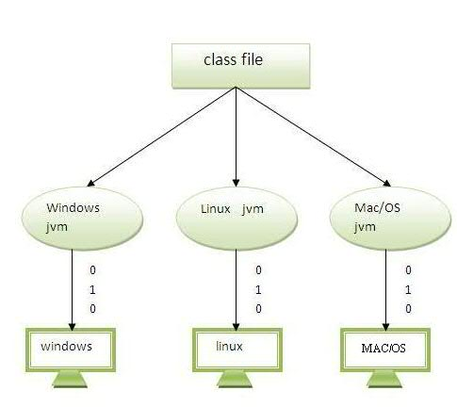
Note: The slogan of SUN microsystem is WORA-WRITE ONCE, RUN/REUSE ANYWHERE.
Note: The OS DOS understands every application in its own understanding format called MOZARTA (M2) whereas UNIX operating system understands in Embedded Linking Format (ELF).
- Architectural Neutral:
Architectural neutral applications are those which are running on every processor (hardware system) without considering their architectures and vendors.
The languages like C, C++ are treated as architectural neutral dependent because C, C++ software’s is not able to convert automatically from the factors of one processor to another factor of another processor.
Java is not tied to a specific machine or operating system architecture.
Machine independent i.e. Java is independent of hardware.
The language like Java and whose applications are by default treated as architectural neutral because the software of Java (JDK) contains some special programs which will convert from one factor of one processor to another processor of another processor.
Note: The basic aim of SUN microsystem is the Java programmer shouldn’t think about operating system and processor compatibilities.
- Portable:
A portable application is one which execute on every operating system and processor without considering their architecture and vendors.
The languages like C, C++ applications are not portable; because either OS or processor is different they are unable to run by default.
Java programs can execute in any environment for which there is a Java run-time system (JVM). We may carry the java bytecode to any platform.
The language like Java whose applications runs on every OS and processor by default. Hence Java is one of the portable languages.
According to SUN MICRO System,
portability is platform independent + Architectural neutral.
Note:
Industry is always recommended to use portable languages for development of distributed application. If we choose non-portable languages for development of distributed applications then the team of software engineers has to spend more amount of time or considerable amount of time to convert non-portable to portable by writing some special programs.
Note:
Being architectural-neutral and having no implementation dependent aspects of the specification makes Java portable. Compiler in Java is written in ANSI C with a clean portability boundary which is a POSIX subset.
Portable Vs Architectural neutral:
For architecture neutral the compiler will generate an architecture-neutral object file meaning that compiled Java code (bytecode) can run on many processors given the presence of a Java runtime.
For portable it means there are no implementation-dependent aspects of the specification. For instance in C++ an int can be 16-bit, or 32 bit depending on who is implementing the specification where as in Java an int is always 32 bit.
- Multi-threading:
The basic aim of multithreading is to achieve concurrent execution.
Thread:
A flow of control is known as Thread.
The basic usage of thread is to execute user/programmer defined methods (functions).
Multithread
If any Java program is containing multiple flow of controls then the Java program is known as Multithread.
The languages like C, C++, Pascal, COBOL, etc., are treated as single threaded modelling languages because their execution environment contains single flow of control. Using these languages, we can achieve sequential execution but not concurrent execution and moreover these languages don’t contain any predefined library for development of multithreading applications.
The languages like Java and .Net are treated as multithreaded modelling languages, because their execution environment contains multiple flows of controls. Using these languages we can achieve both sequential and concurrent execution and moreover the language Java contains an effective library for development of multithreading application.
The library for developing multi-threading applications is:
- java.lang.Thread (class)
- java.lang.Runnable (interface)
The real time implementation of multithreading concept is that to develop real world servers such as Tomcat, WebLogic, WebSphere, oracle10g servers etc.
Each and every Java program contains default two threads. They are
Foreground/child thread:
A foreground thread is one which is always executing user/programmer defined methods. By default there exists a single foreground thread. But as a programmer there is a possibility to create multiple foreground threads to execute multiple methods concurrently.
Background/Parent thread:
A background thread is one which is always monitoring the execution status of foreground thread(s). By default there exists single background thread and always recommended to have single background thread even programmatically per Java program.
Therefore, in a Java programming execution environment it is highly recommended to have multiple foreground threads and a single background thread per Java program.
Multithreading is one of the specialized distinct feature of Java which was brought from multi-tasking concept of OS.
How do you justify every Java program is multithreaded?
Whenever we execute any Java program, to execute the programmer logic there exist one thread known as foreground/child thread.
To monitor the execution status of foreground thread, internally one more thread is executing (garbage collector) and it is known as background Thread.
Hence, in every Java execution environment there exist multiple threads. So, that we can say every Java program in multithreaded.
Note:
It is highly recommended to the Java programmers not to create unnecessary flow of controls because unnecessary flow of controls leads to inconsistent/dead lock result which is not recommended.
The main advantage of multi-threading is that it shares the same memory. Threads are important for multi-media, Web applications etc.
- Networked:
The basic aim of networking is to share the data between multiple machines either they are located in same network or located in different network.
“Collection of interconnected non-autonomous/autonomous computers” is known as Network.
According to industry standards, we have two types of networks. They are:
- Untrusted network.
- Trusted network.
An untrusted network is one in which there exists “collection of interconnected non-autonomous computers”. Using J2SE (network programming), we can develop the applications for running on untrusted network architecture and these types of applications are known as Internet Applications.
Intranet applications are those which are able to run and whose result is able to share within the limited distance. These applications are preferred by those organizations whose business operations are available within the limited place (known as Scale Organization).
A trusted network is one in which there exists “collection of interconnected autonomous computers”.
Using J2EE technologies (servlets, JSPs, EJB etc.), one can develop internet applications to run on trusted network architecture.

Internet applications are those which are able to run and whose result is able to access across the globe. These applications are preferred by those organizations whose business operations spread across the globe (known as large scale organizations).
Finally, Java programming is containing an effective library for development of network oriented applications.
Note: Network oriented applications are either internet applications or intranet applications.
- Distributed:
According to industry standards, a java project can be developed in two ways:
- Centralized application development.
- Distributed application development.
Centralized application development:
It is one which runs on the context of single server.
In real world, centralized applications will not be having public URL.
Example: SBI bank application can be accessed by only the employees of SBI but not by other public people.
The limitation of centralized application is that once the server is down, clients are unable to communicate unless and until server is uploaded, i.e. we get less availability of data.
Java Project

Server

Cn-1
Cn
C4
C3
C2
C1

Distributed application development:
A distributed application is one which is running in the context of multiple servers and whose results are able to access across the globe.
All the real world websites are the examples of distributed applications (www.mail.yahoo.com, www.gmail.com, etc.). Every distributed application will be having public URL.
Java was designed with the distributed environment. RMI and EJB are used for creating distributed applications. We may access files by calling the methods from any machine on the internet. Java can be transmit, run over internet.
Java is distributed programming language because it has provided number of technologies like Socket programming, RMI, CORBA, EJB’s and Web Services to design distributed applications.
Designing a java application on the basis of client-server architecture is called as distributed application.
The advantage of distributed applications is that even though one server is down, clients are able to communicate from other servers. So, that we get more availability of data.
The negligible drawback of distributed applications is that designing cost of the servers is more.
Java Project

S3
S2
S1

Cn
C2
C1

What is difference between the URL and URI?
The place where the application is running is known as URL, whereas place where the application is residing is known as URI.
- High Performance:
Java is faster than traditional interpretation since byte code is "close" to native code still somewhat slower than a compiled language (e.g., C++)
Java is one of the high performance programming languages because of the following points.
- Execution time of an application is very less compared to any programming languages because of the magic of the byte code.
- Java programming run time environment automatically provides automatic memory management (garbage collector).
- We know that java programming doesn’t support pointers concept. So, that a complex concept is eliminated from Java programming and one can develop the program as early as possible. It gives more performance to programmer that is programmer performance is improved (according to industry).
- Bytecodes are highly optimized. JVM can execute them much faster.

- Interpreted:
Java is both completive and interpretative, where to compile java applications, we must use “JAVAC” compiler and to execute java applications, we must use interpreter in java.
In the initial versions of java, compilation phase is so faster and interpretation phase is very slow. This was the compilation given by industry to the SUN MICROSYSTEM.
SUN MICRO System developed set of programs named as JIT (Just In Time Compiler) and added as a apart of JVM for speedup or strengthening the interpretation phase.
In the current versions of Java interpretation phase is so faster than compilation phase of Java.
Therefore, Java is one of the highly interpreted programming languages.
Define JIT?
JIT is the set of programs developed by SUN MICRO System and added as a part of JVM to speed-up the interpretation phase.
JIT reads the entire section of the byte code and converting into native understanding form of OS.
- Robust (Strong):
Robust simply means strong.
If any programming language is good at memory management system and at exception handling mechanism, then that programming language is Robust programming language.
In the languages like C, C++, if we enter any invalid input then that program will be closed without iving any appropriate message which is not recommended. This indicates the languages called C, C++ are not robust languages. Because they are unable to solve runtime problems.
Java is a Robust programming language, because:
- Java programming language is having very good memory management system in the form of heap memory management system, which is a dynamic memory for the objects at runtime as per application requirement.
- Java programming language has very good exception handling mechanism, java has defined very good predefined library to represent each and every exceptional situation in order to handle.

Note:
Java technology provided very good environment even to handle user defined exceptions or custom exceptions.
Note:
Run-time errors of the program are known as Exceptions.
Define Compile-time errors and run-time errors?
Compile-time Errors are those which are resulted when the programmer is not following syntax rules of the language.
Run-time Errors are those which are resulted when the normal user enters invalid input at run-time.
- Dynamic:
In any programming language, memory can be allocated in two ways. They are:
a) Static memory allocations.
b) Dynamic memory allocations.
Static memory allocations:
A static memory allocation is one in which memory will be allocated at compile time.
Because of static memory allocation we get the following limits.
- Waste of memory space (the number of values we enter at run time are less than the size of the array).
- Loss of data (The number of values we enter at run-time are more than the size of the array).
- Overlapping of existing data (if an array is containing full of values and if you are trying to insert a new value within the existing memory location, because as a programmer we are unable to move the elements either downwards or upwards).
Java programming will not follow static memory allocation but it always follows dynamic memory allocation because the concept of dynamic memory allocation eliminates the limitations of static memory allocation.
A dynamic memory allocation is one in which memory will be allocated at run-time by using new operator and the operator is known as ‘Dynamic Memory Allocation’.
- Secure:
Security:
Security is one of the principle used in the software industry to prevent or protect the confidential information from unauthorized users and unauthorized users are those which doesn’t have security ‘credentials’ such as username, password, barcode, pin, etc.
Java is secured because:
- No explicit pointer
- Programs run inside virtual machine sandbox.
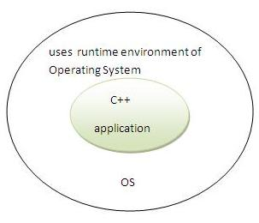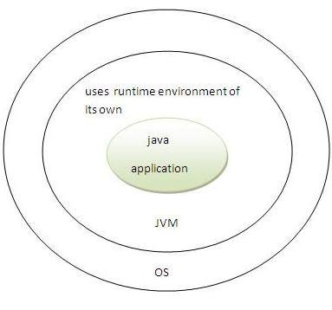
Classloader - adds security by separating the package for the classes of the local file system from those that are imported from network sources.
Bytecode Verifier - checks the code fragments for illegal code that can violate access right to objects.
Security Manager - java has provided separate component in the form of security manager inside JVM which determines what resources a class can access such as reading and writing to the local disk. It helps to manipulate implicit security.
These securities are provided by java language. Some security can also be provided by application developer through SSL,JAA [Java Authentication and Authorization Service, to provide web-security in web applications],cryptography etc.

With Java's secure feature it enables to develop virus-free, tamper-free systems. Authentication techniques are based on public-key encryption.
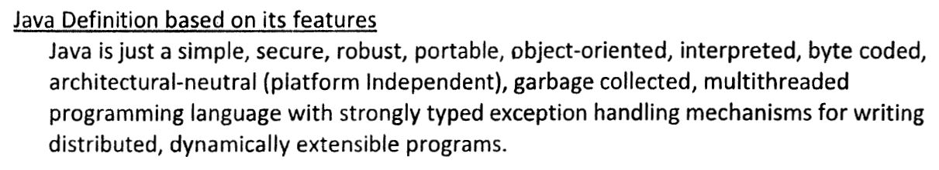
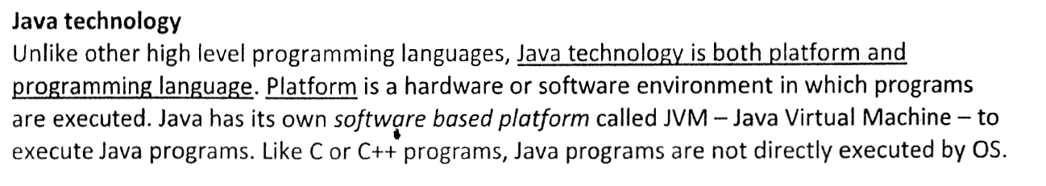
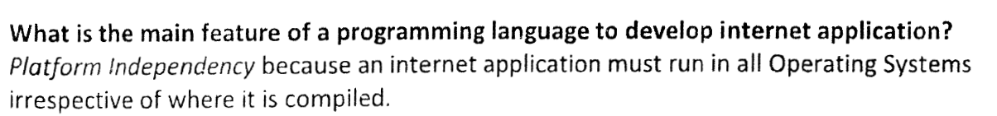
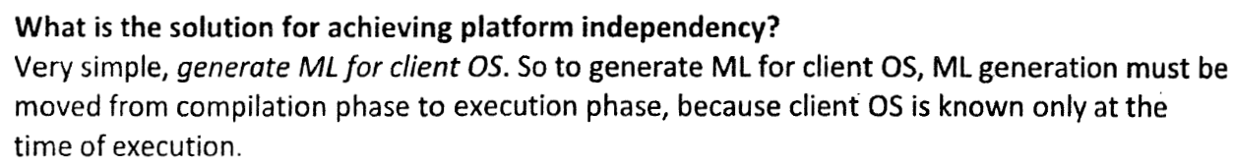
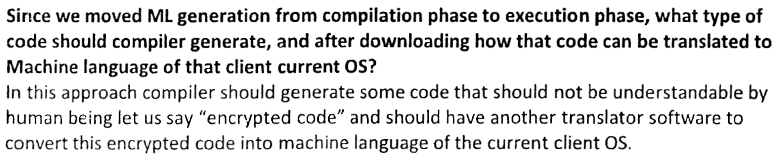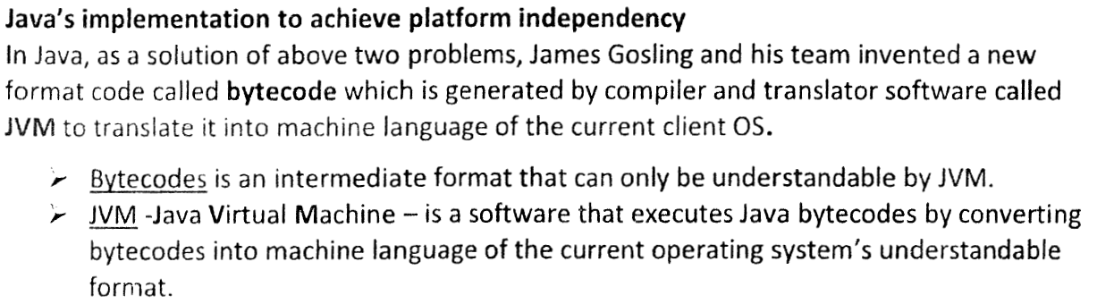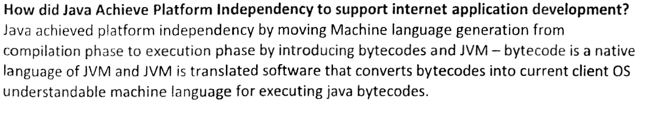
Platform independence in Java- WORA and WOCA
Java was conceived by James Gosling, Patrick Naughton, Chris Warth, Ed Frank and Mike Sheridan at Sun Microsystems, Inc in 1991. Initially it was called Oak, later it was changed to Java in 1995.
- Java's primary motivation was platform independence and not internet. Platform independence means the ability to write a program on one platform and run it on any other platform without worrying about the platform specific features, which is nothing but portable software. If it works on one platform, it should work on all other platforms. e.g., platforms are Unix , Mac, Windows, Android. The main motive behind Java invention is to introduce a feature called Java Portability.
- Platform independence could be achieved for a C/C++ program, by compiling it for every platform. But C/C++ compilers are expensive to build and also there could be differences between platforms which cause inconsistencies in the program execution. So achieving portable software using C/C++ is difficult and error prone. This is also referred as WOCA = Write Once, Compile Anywhere.
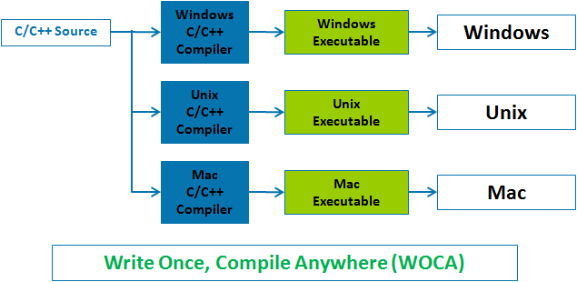
- A simpler cost effective solution is to use portable, platform independent code that runs on variety of CPU's under different environments. Java uses Java Bytecode, which is an intermediate set of instructions that helps achieving this platform independence. This is also referred as WORA = Write Once, Run Anywhere.
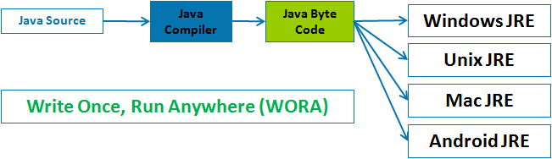
- World Wide Web (Internet) made Java more important. Since Internet is connected with systems of different CPU's and environments, it is required to have programs which run on any CPU or operating system or platform. Since Java was platform independent and could run on all the famous platforms like Intel, Mac, Unix etc., it was extensively used. So most of the new internet programs were written in Java making it more famous. More details available at Java And Internet - Creating Java Applet.
- Java is not 'Internet version of C++'. Although Java is similar to C and C++, Java is not designed to replace them. Java uses the syntax of C and improves on the Object oriented (OO) concepts of C++. But there is additional support in Java for internet programming. Also Java and C++, are not code compatible, which means code written in one language cannot be compiled in the other language. So if we want to change a program from C++ to Java, it has to be completely rewritten. But programmers experienced with C and C++ can easily learn Java and rewrite the code.
Java and C/C++ will continue to coexist, since Java solves certain problems and C/C++ solves certain other problems.
- Java and C# connection Java's innovative features, constructs and concepts have become part of baseline of any new language. C# created by Microsoft is very similar to Java. This is a good example which emphasizes the importance and usage of Java as a computer programming language.

